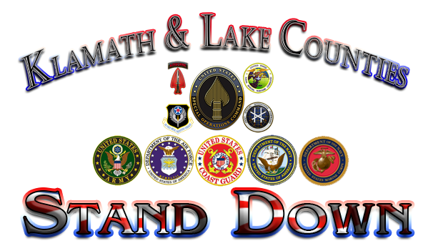
June 17th, 2022
Klamath County Fairgrounds’ Linman Hall
Klamath Falls, OR 97603
Helping Vets Stand Up Through Our Stand Down

The Klamath & Lake Counties Stand Down will be hosting its 12th annual event on June 17th, 2022. This event was established to ensure that all Veterans, active service members, and their dependents are receiving all the benefits and services they are eligible for. Past Stand Down events have been made possible due to the support of this community, and we are once again requesting your support. Please consider donating to this wonderful event to ensure that some of our most valued community members continue to receive the assistance they need.
The types of assistance we are in need of are volunteers at the event and financial donations. All donations received will be used to purchase food, water, hygiene items, building rental, and the purchase of cold weather items such as sleeping bags, tents, and socks. The expense for this essential event is approximately $12,000.00.
Please post a flyer in your business if you are able and refer any Veterans you come in contact with to this event. If you are a business that provides services to Veterans and would like a booth at this event, please contact
For more information, contact: Tammi Deforrest @ tdeforrest@veteransenrichmentcenter.org
or 541-331-9975. Mailing address: PO Box 931 Klamath Falls, OR 97601

*This event is Friday, June 17th, 2022 from 9:00 a.m. until 2p.m.

